Melomel with Raspberry and Cranberry

The justification for making a mead with raspberries (melomel) comes primarily from R. Gayre [2, pp 118]:

Prominent, and indeed famous, among those liquors closely related to mead is what, for want of a more specific name, one would call raspberry sack-mead. This, as a sweet liquor, was greatly prize in Poland before the late war. One old writer quoted by Edward Spencer(191) tells of its being obtainable in Sweden, Muscovy, and as far as the Caspian Sea. This consists of the juice of raspberries and honey fermented together. It is by no means an easy liquor to make, as there is a strong tendency to vinegrate unless it is made with skill and care.

The proportions of honey and water are based on several recipes in Digbie[1], notably:

TO MAKE MEATH (Digbie, pp. 92)
Take to six quarts of water, a quart of the best honey, and put it on the fire, and stir it, till the honey is melted: and boil it well as long as any scum riseth: and now and then put in a little cold water, for this will make the scum rise: keep your kettle up as full as you did put it on; and when it is boiled enough, about half an hour before you take it off, then take a quantity of Ginger sliced and well scraped first, and a good quantity of Rosemary, and boil both together. Of the Rosemary and Ginger you may put in more or less, for to please your taste: And when you take it off the fire, strain it into your vessel, either a well seasoned-tub, or a great cream pot, and the next morning when it is cold, pour off softly the top from the settlings into another vessel; and then put some little quantity of the best Ale-barm to it and cover it with a thin cloth over it, if it be in summer, but in the winter it will be longer a ripening, and therefore must be the warmer covered in a close place, and when you go to bottle it, take with a feather all the barm off, and put it into your bottles, and stop up close. In ten days you may drink it. If you think six quarts of water be too much, and would have it stronger, then put in a greater quantity of honey.

Lastly, Digbie also shows the use of raspberries as an ingredient in fermentation:

TO MAKE RASBERY-WINE (Digbie, pp 148)
Take four Gallons of Deal wine, put it into an earthen jugg; put to it four Gallons of Rasberries; let them stand so infusing seven days; then press it out gently ; Then infuse as many more Rasberries seven days longer, and so three times if you please; put to it as much fine Sugar as will make it pleasant; Put it into a Runlet close stopped, let it stand still till it is fine; and then draw it into bottles, and keep it till it be fine.

Additionally, several sources (which I could not find at the moment) show that brewers of the period often used whatever fruits were available to them when flavoring their melomel therefore I also used cranberries, which combines nicely with the flavor of the raspberries.

The Process:
The honey and half of the water were heated and the must was skimmed. After cooling, I added the must (with the remaining water and the juice to cool it faster). Having pre-started the yeast, I then added that to the carboy as well. It fermented for 5 months and I bottled it once the process was completed. This mead was not racked during the brewing process.
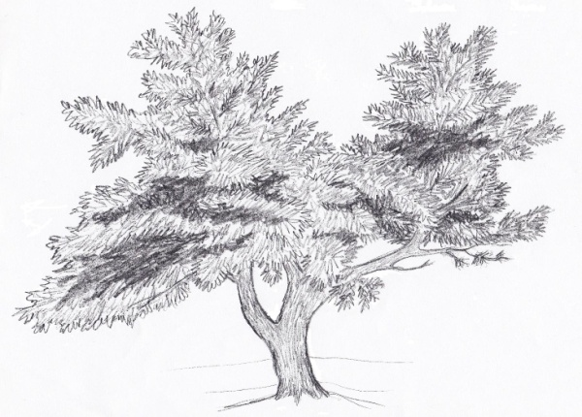
Ingredients:

15 pounds honey
4 gallons of water
1 gallon Cran-Raspberry juice
1 packet Coopers brewer’s yeast

