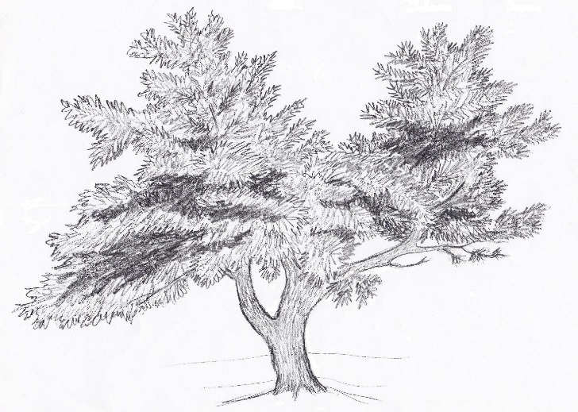
Orlovsky's Mead

Ingredients:
Honey 1 gal. (12 lbs)
Water 3 1/4 gallons
Lemon rind 6 pared
Ginger root 1 oz, thinly sliced
Hops 1 cup fresh dried hops
Salt 1 tablespoon
Yeast one Packet mead or Vierka wine yeast.

The Process:
1. Honey and 2 gallons of the water in a pot to heat up.
2. Add lemon rinds, ginger, salt, and 3/4 cup of the hops
3. Stir and slowly bring to a boil, slow boil for 45 minutes
4. Remove from heat, sprinkle remaining hops on the top
5. Allow to cool in a bucket adding remaining water. Then strain it.
6. Add yeast at 90-95 F. Let ferment for 3-4 months until done.

History:
The above was the original recipe I had gotten from a bee keeper friend of mine. He said he got this 30ish years ago from an old Russian friend who also kept bees and was in HIS seventies at the time. Apparently it was an old family recipe.

Tweaking the recipe:
We tried the above as is found it a little dry so we made these changes.

Increased the honey to 15 lbs
Measured out 3/4 oz of dried lemon peel
Upped ginger to 3.5 oz.
Then we made it the same as above on 3/12/13 and that is what is in the bottle that accompanies this recipe.

