June 3rd, 2013

Mistress Mercedes Vera de Calafia
New Groups Deputy Senechal
Kingdom of the East

Re: Request to form a new canton in the Barony of Endewearde

Greetings unto Mistress Mercedes,
On May 2nd, 2013, approximately a dozen citizens in the southern reaches of the newly elevated Barony of Endewearde met and discussed their desire to form a canton in their area. In addition, others known to be participants in the Society for Creative Anachronism and to live in the same area have been solicited for their opinion with both an informal group on Facebook formed to interact and a more formal group on Yahoo (http://groups.yahoo.com/group/EndeweardeCanton/) . To date, where those contacted have responded, their hope and desire has been expressed as pursue this action; not isolate themselves from the barony but to strive to create a more direct local representation of the Society for Creative Anachronism which will enable them to better organize and promote SCA development and activities in the area.
Volunteers were requested and agreed upon and it is therefore with pride, that I, Syr Cedric of Thanet, humbly submit the following on behalf of the people of the proposed canton of Windridge in the Barony of Endewearde, East Kingdom.

1: Preference pollings have been circulated amongst the local populace. The preferred name at this time is: The Canton of Windridge. Initial feedback from Mistriess Brita Svensdottir, baronial herald for Endewearde and (via Mistress Mercedes) Mistress Alys MacIntosh, Eastern Crown Herald indicates that a more medieval spelling may be required, such as Wyndriche but so far, no conflict has been identified with existing SCA groups. In pursuing the canton name, flexibility will be maintained to work through the heraldic process and work with their suggested modifications. Initial consultation for name acceptability has been initiated with Mistresss Brita Svensdottir – the baronial herald for Endewearde. The plan is to instigate formal submittal for a branch name upon approval of this missive.
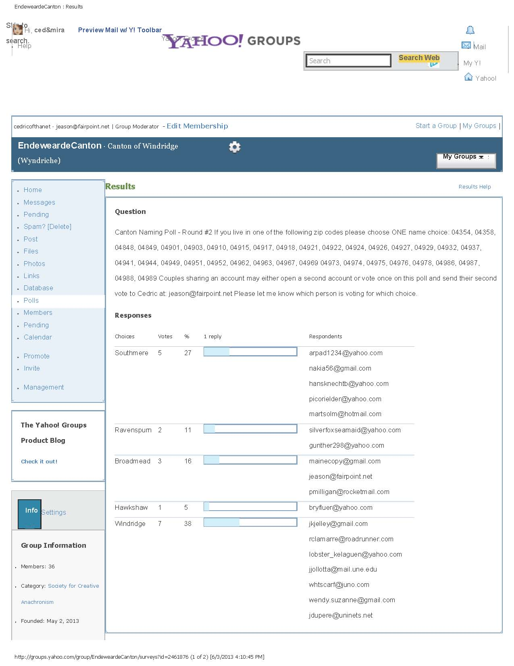

2: The proposed zip code list has been reviewed with Lord Otto Gottleib (seneschal for the Barony of Endwearde). All zip codes are believed to be currently listed under the barony, though the proposed area adjoins the Province of Malagentia and the Incipient Shire of Hadchester. The list is given below. Please note that the zip code for Windsor, Maine (04363)– currently part of Endwearde and a likely inclusion to this area is intentionally left off the list. It is understood that the Shire of Hadchester has or shortly will be requesting this zip code with residents in that area noting their preference to become part on the incipient shire. This matter has been discussed with both the seneschals of Hadchester (Lord Thomas Winterwade) and Endewearde (Lord Otto Gottleib).
Proposed zip code list:
Municipality | Zip Code
Palermo | 04354
South China | 04358
Islesboro | 04848
Lincolnville | 04849
Waterville | 04901
Waterville | 04903
Albion | 04910
Belfast | 04915
Belgrade | 04917
Belgrade Lakes | 04918
Brooks | 04921
Burnham | 04922
Canaan | 04924
China | 04926
Clinton | 04927
Detroit | 04929
Dixmont | 04932
Fairfield | 04937
Freedom | 04941
Hinckley | 04944
Liberty | 04949
Monroe | 04951
Morrill | 04952
North Vassalboro | 04962
Oakland | 04963
Pittsfield | 04967
Plymouth | 04969
Searsmont | 04973
Searsport | 04974
Shawmut | 04975
Skowhegan | 04976
Smithfield | 04978
Thorndike | 04986
Troy | 04987
Unity | 04988
Vassalboro | 04989
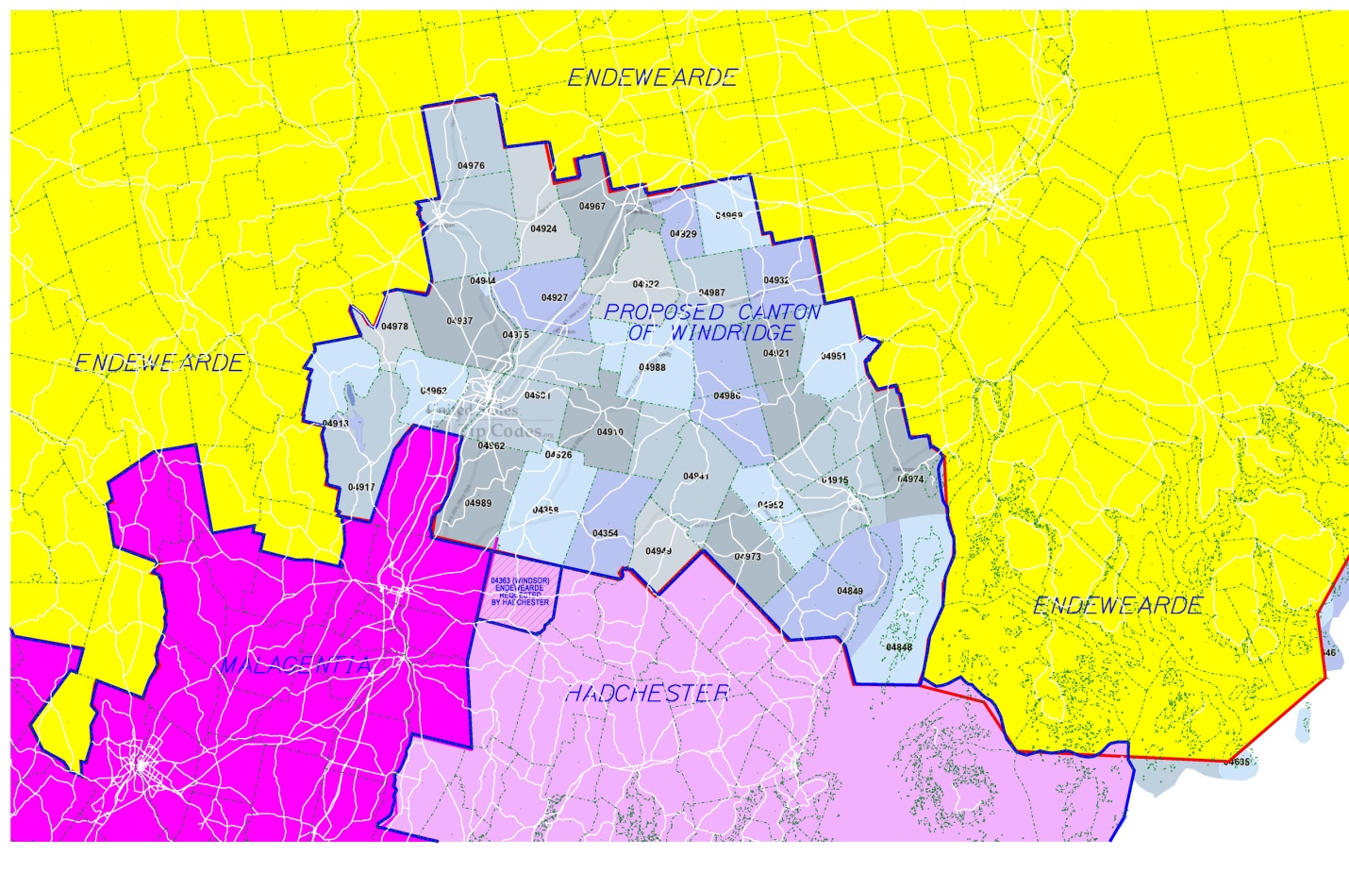
3. The proposed initial slate of officers is as follows:
Seneschal – Syr Cedric of Thanet - James Eason, 118 Bog Brook, China ME
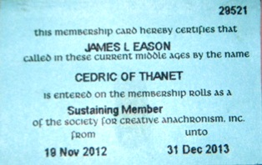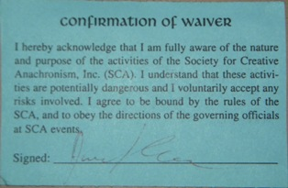
Deputy Senechal – Lord Kettlemetlin Arpad – Bruce Grantham - 116 Parsons Valley Road, Thorndike, Maine 04986
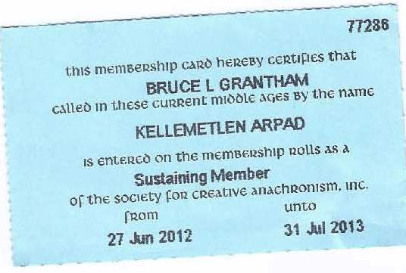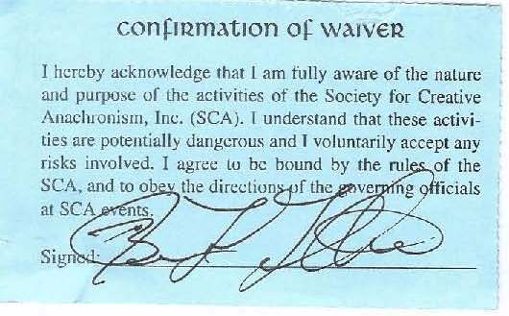
Arts and Sciences Officer – Lord Hew of Albion – Matt Martsolf - Albion Maine26 Unity Rd #1
Albion, ME 04910
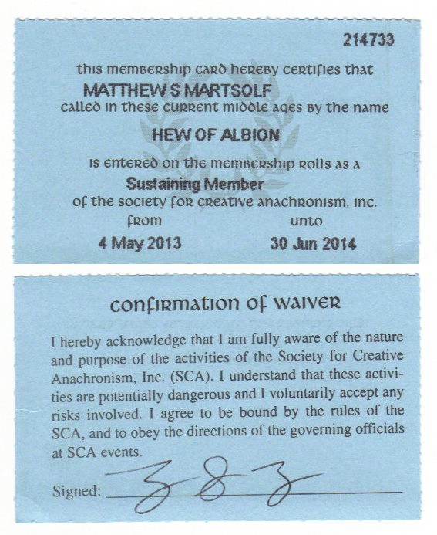

Chatelaine – Lady Anna Tarr – Carrie Johnston, 42 Murdock Drive UC Box 82, Unity College,
Unity, Maine 04988
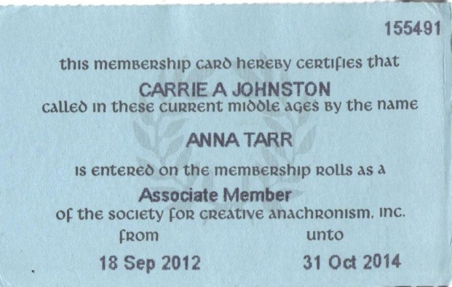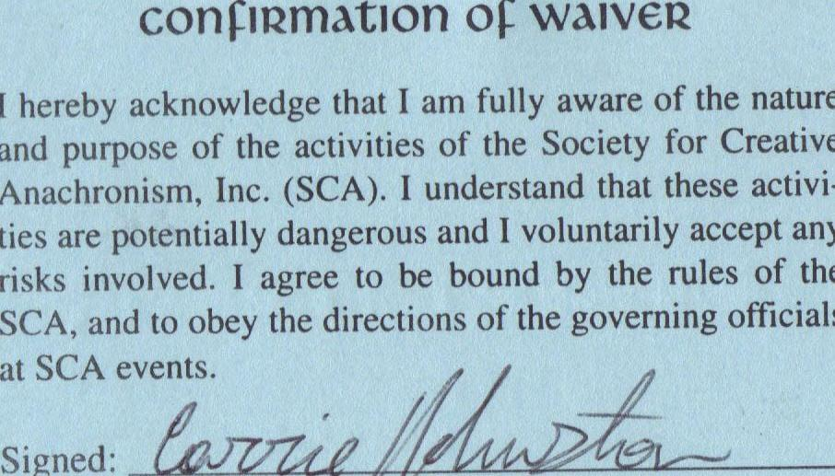
Exchequer – Don Jehan Fitzallan – mka Joe Dupere Unity Maine – pending information
Deputy Exchequer - Janet Nadeau – Waterville – Maine - pending
Our intent is to work with the appropriate kingdom, regional and baronial officers to insure the acceptance of all of these officers with the approval of this missive.

4. Letter from the seneschal of Endewearde for canton support and sponsorship: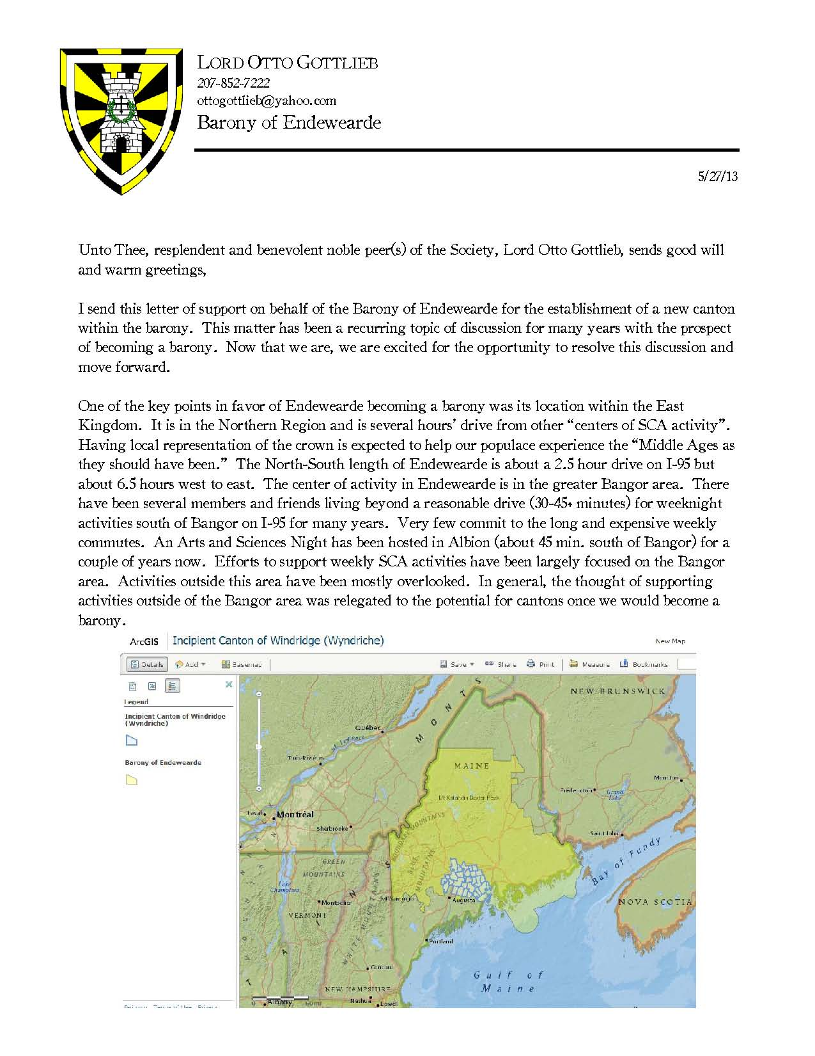

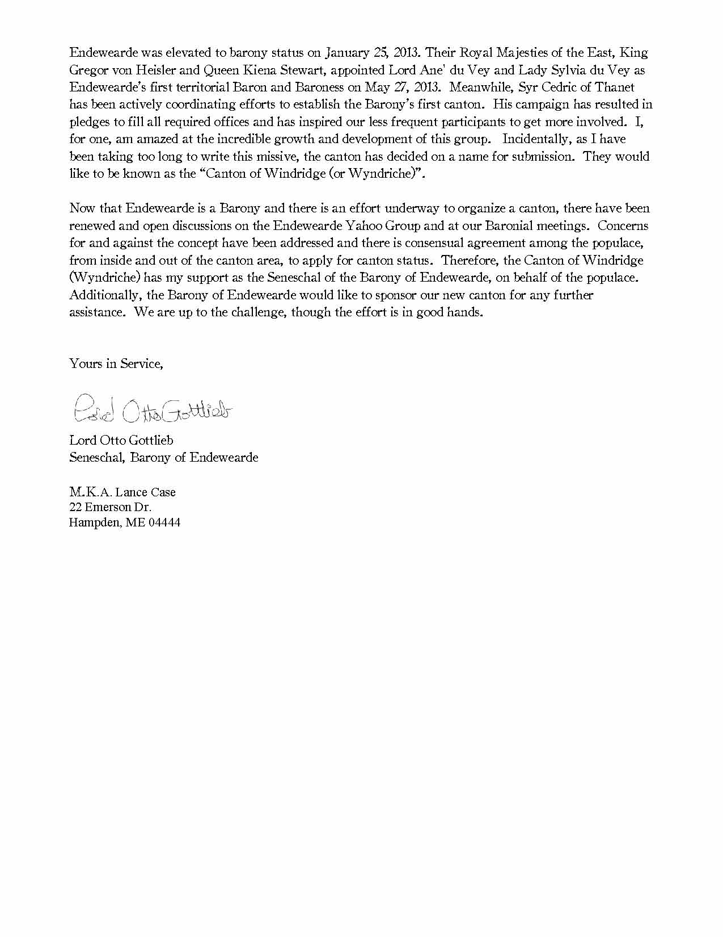

5: Letter of support from incoming baronial heads:

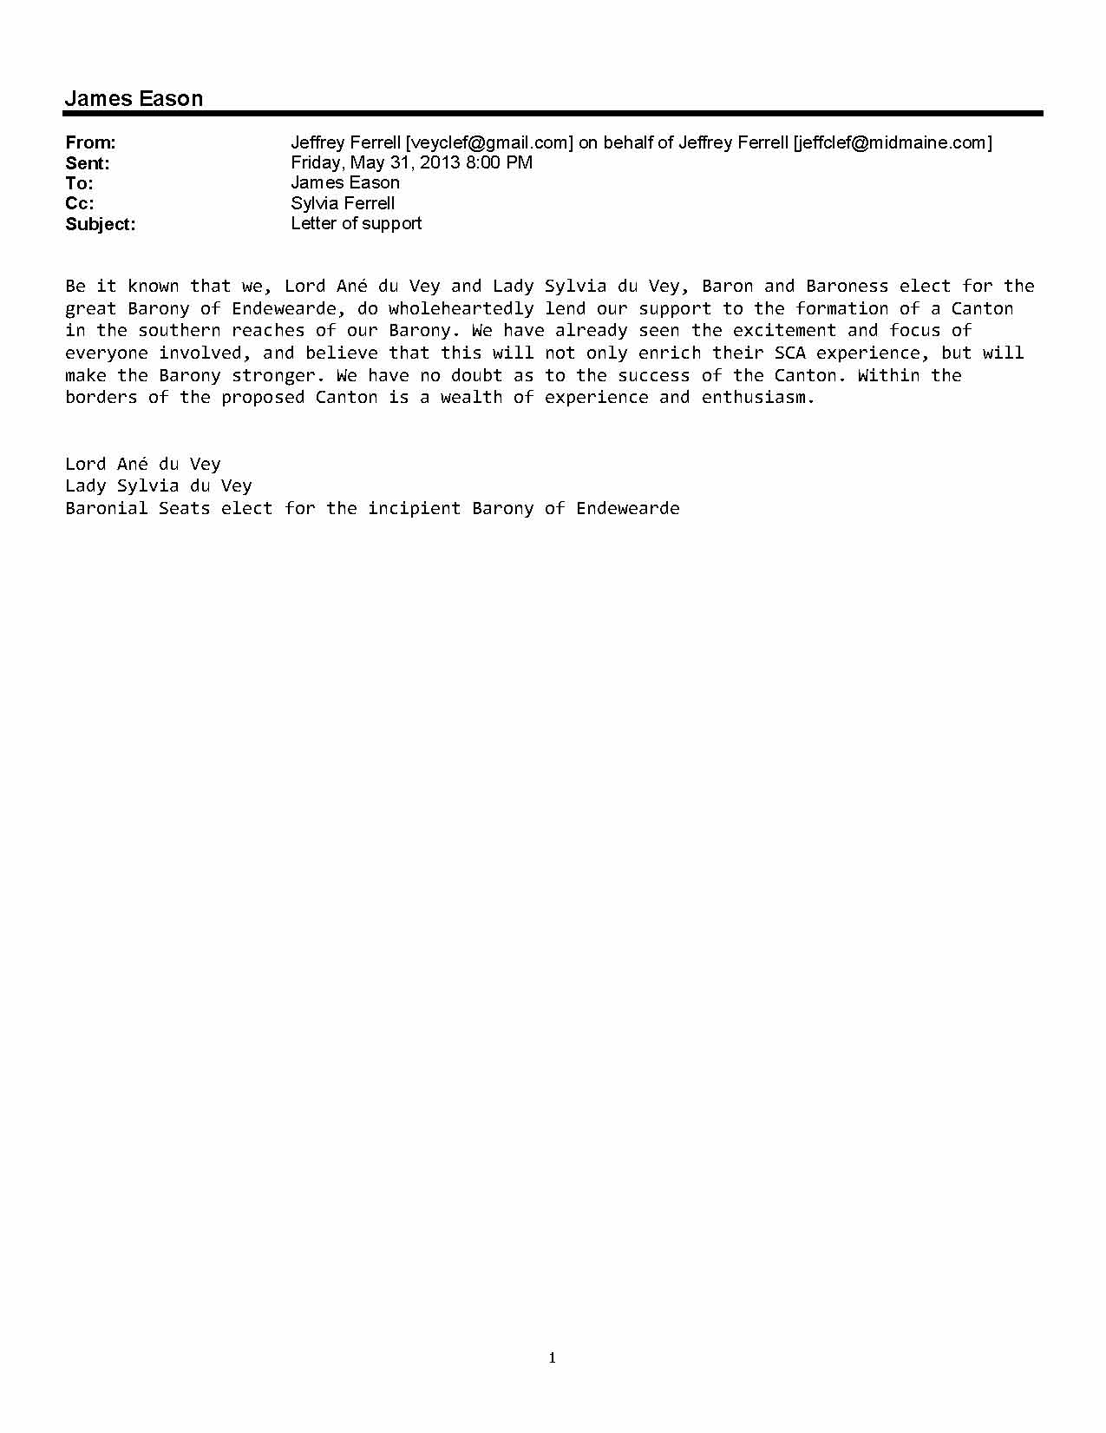
With the exception of the pending officer information from Don Jehan for exchequer, I believe the enclosed information completes the required information for approval to incipiency. If I am incorrect in this assessment or if there is more information needed, please, let me know.
Upon acceptance of this information, I would like to also make two requests:
1. That we begin the process of requesting mailing addresses to formulate the formal petition process
2. That I be added to the seneschal’s roster for Windridge and Lord Arpad as my deputy so that we may begin working with the kingdom officers to warrant the remaining officers needed to fulfill our core officer requirements.

I thank you for your time and care in this matter,

In service to society, kingdom, barony, and canton,
Syr Cedric of Thanet
Syr Cedric of Thanet (pending seneschal for the canton of Windridge)
mka: James L. Eason – China, ME

Cc: Mistress Hedewigis Ockenfüssin – Seneschal – East Kingdom
Lord Dafydd o Llyn Cwellyn - Northern Region Deputy Seneschal – East Kingdom
Lord Otto Gottleib – Seneschal – Barony of Endewearde
Lord Anè du Vey and Lady Sylvia du Vey – Baron & Baroness Elect - Endewearde
Lord Kettlemetlin Arpad – Proposed Deputy Seneschal – Proposed Canton of Windridge
Don Jehan Fitzallan – Proposed Exchequer – Proposed Canton of Windridge
M’Lady Janet Nadeau – Proposed Deputy Exchequer – Proposed Canton of Windridge
Lord Hew of Albion – Proposed Arts and Sciences Officer – Proposed Canton of Windridge
Lady Anna Tarr – Proposed Chatelaine – Proposed Canton of Windridge

